Instruction sheet

Building sustainability with concrete

Caution: You must wear a lab coat, safety glasses, and gloves in this practical
You MUST wear a face mask when mixing the dry ingredients.

Making concrete
- Decide which variable you are going to test.
- Determine which ingredients are the Cementous material, fine and course aggerate and water source.
- In a paper mixing cup combine 2 parts Cementous material, 4 parts fine aggregate and 2 parts coarse aggregate.
- Add a small amount of water and mix.
- Keep slowly adding water until your concrete is wet but not runny.
- Put some of your concrete mix into a small, tall, thin cup, and flatten it slightly.
- On the outside of the cup, use a marker to indicate the height of the mix.
- Flip the cup upside down onto a piece of paper on the table.
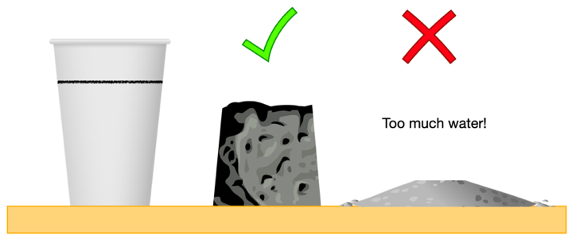
- Tap the cup and lift it straight up. The concrete will ‘slump’ a little.
- Stand the inverted cup next to your concrete. Compare the two heights.
- A good mix would be that it has ‘slumped’ about 20% of its original height.
- Scoop up the slump back into your mixing container.
- When your concrete mix is ready pour it into the ice stick tray
- Tap the tray on the table to remove any air bubbles.
- Using a skewer or stirring stick, stab the mix several times to get the last few air bubbles.
- Give each pillar a number and label the tray with a waterproof pen and marker.
- Place the completed tray in a larger tub of water.
- Store them at room temperature for at least 7 days -ideally 14 days or longer.
Testing concrete
- Remove the concrete pillars from the ice stick tray ensuring you know which pillars were made using which ingredients.
- Conduct three different tests on the concrete pillars;
Hanging Weight Test: Clamp one end of the concrete pillar to the edge of a table, slowly hang weight off the other end of the concrete until it breaks. Record how much weight it takes to break the concrete. (Hint: Place something soft underneath where the weights will land after the concrete breaks and make sure to keep your feet far away. Some concrete pillars may require more than 10 kg)
Clamp test: Place the ends of the concrete in a clamp or vice and squish the concrete until it breaks. Record how many turns of the vice it took to break the concrete.
Dropping Weight Test: Place you concrete in a small tub, using small light weights drop the weight from a small height onto the concrete. Increase the weight slightly each time until the concrete breaks (Make sure you drop the weight from the same height every time)
- Collect all the results to determine which ingredients were the most effective at creating a strong concrete.

